Use of Data Access Tools: EnCase Investigations

Ifeanyi Uzoukwu

September 2nd, 2021

CST 640

University of Maryland Global Campus

**Introduction**

Creating a forensic image of a device is the most crucial step in obtaining evidence from a potential threat actor. A forensic image allows the forensic examiner to see a complete copy of unaltered electronic information, which can range from a simple file to an expansive hard drive When a forensic image is obtained, the examiner can peruse its contents without having to change or modify the original information stored on the device. There is a plethora of forensics tools that allow a user to extract forensic images from a device. The goal of the following report is to provide understanding of how to use one of the most popular Forensics Analysis tool in FTK Imager.

**Lab 1: Creating an Image in FTK Imager**

Forensics Investigators need to have a solid understanding of where digital evidence can be found and the different mediums that hold information. Forensics Investigations also need to be aware of the many methods that threat actors and cyber attackers tend to use. For the purpose of training our forensics investigators, I am conducting a lab in which I will create an image using the FTK Imager tool. FTK Imager is an extraction tool for analyzing media, that is well known and highly regarded by forensics examiners.

1. After logging into the WINFOR01 virtual machine, and opening FTK Imager, I selected the following source path: C:\ Users\StudentFirst\Pictures\Sample Pictures.

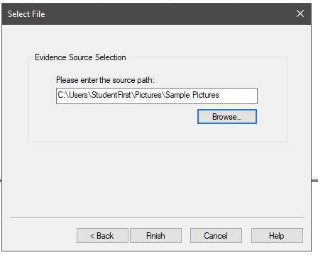

1. After selecting the source path, I filled out the Evidence Item information. 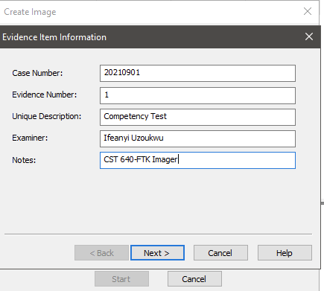
2. After verifying the image results, I was able to confirm that the MDA5 and the SHA1 hashes were the same.

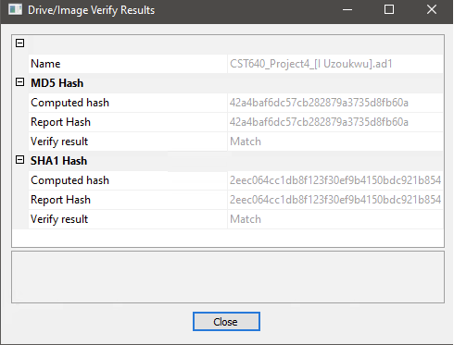

1. After adding the AD1 image (CST640_Project4_[IUzoukwu].ad1) that was created in the previous steps to the evidence tree, we can see that there are multiple pictures available to view.

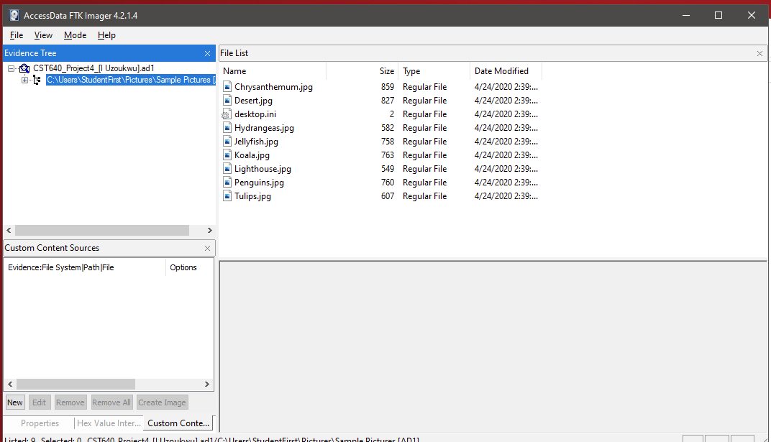

1. This is the picture of the Chrysanthemum.jpg file. This photo was found under the following path: **C:\Users\StudentFirst\Pictures\Sample Pictures\Chysanthemum.jpg**



1. This image shows the CST640_Project4_[IUzoukwu].ad1.txt file opened in Notepad, this file shows a summary of the information filled out during the Image verification results, and the matching SHA1 and MD5 sums.

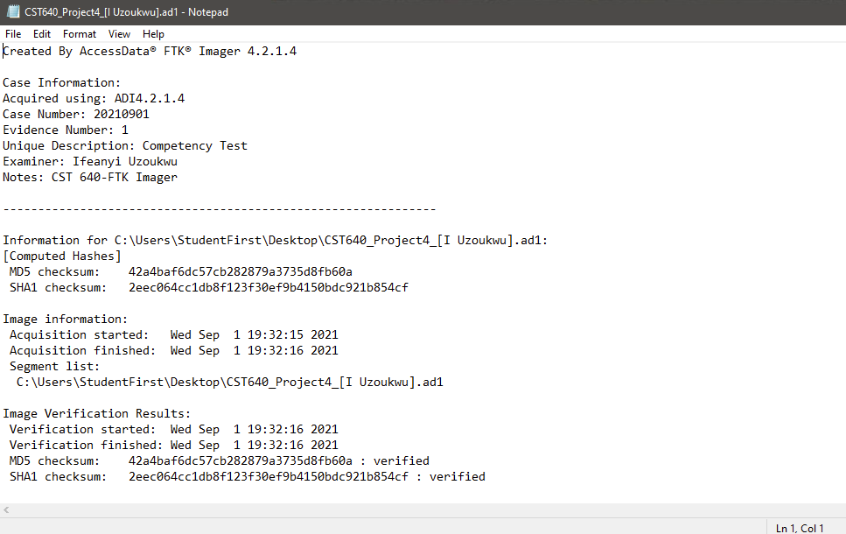

**Lab 2: Creating an Image off of Suspect Mantooth’s Computer**

Finding certain sets of data, such as the Metadata, which are datasets that describe other datasets. File systems manage the data stored on physical media, the three types are New File Technology System (NFTS), File Allocation Table (FAT), and the Extended File System (EXT). Hexadecimals refer to an alternate encoding technique that translates computer language from binary. Hexadecimals use a base-16 system (numbers 0-9, letters A-F). The American Standard Code for Information Exchange (ASCII) is the standard for the conversion between binary numbers and nonnumerical data.

When a forensic investigator submits an evidence report, it must meet multiple standards once it is submitted into a court of law. Evidence reports must be through, accurate and readable. When evidence is presented in the report, its facts, as well as the conclusions drawn from the evidence and investigations must be presented clearly. The presentation is also important, as the report will be reviewed and parsed through by a jury of people of varying backgrounds.

POLICE DEPARTMENT FORENSIC CASE REPORT

20201113-1001a 9/1/2021

**Mantooth, Wes**

* Credit Card Fraud
* ATM Fraud
* Check Washing
* Email/Phishing Fraud
* Intent to manufacture methamphetamines

**Examination of [media examined]:** On September 1st, 2021, Forensic Examiner *Ifeanyi Uzoukwu* conducted an examination of a Hard Drive at the request of Assistant District Attorney Gerald Kelser.  The allegations, per the request, were Credit Card Fraud.  This examination included a review of emails, documents, saved webpages, and downloaded images available on the hard-drive in question in search of evidence related to the allegations.

**Search Authority:**

Authority to search was granted based upon a court issued search warrant (Mag No. 5:15-BR-549-TLC) Boulder Police Department.

**Items Analyzed:**

Images of the following hard drive:

* Maxtor EIDI hard drive, s/n NAR61EA0, model # 6E020L0, 125MB from DeskStar desktop computer, s/n H3R30R7H3R3, Model # G3N3R1C

**General Procedure Followed:**

Forensic Examiner Ifeanyi Uzoukwu imaged the above described item and made a working copy of image files. The MD5 **db5f00d1abb66928d0e6df2d9d8589fb** and SHA-1 **d8af841e73579c7e7d679427692f481c5050b9ad** of the working copy matched that of the original media. The evidence was checked into the evidence room and all examinations were conducted on the working copy.

Using EnCase Version 8.09, I examined the contents of the aforementioned hard drive, Keyword Search, Index Search, and File Carving searches were used to produce the following evidence.

**Executive Summary:**

The examination of the above describe item support the above-described allegations Email was discovered in this examination that suggest Mr. Wes Mantooth was in communication with Mr. John Washer pertaining to credit card information theft, check washing, and manufacturing methamphetamines.

Additional analysis was required, I was asked to use registry viewer to obtain user account information from Mantooth, a suspect in a case in which the detectives are still looking for information. I am being asked to retrieve the suspect’s full name, his Vehicle Identification Number for the 1992 Dodge Mantooth drives, and a photograph of Mr. Mantooth. As well as a list of his frequently emailed contacts, and possible co-conspirators.

After completing my review of the Mantooth Evidence File, I can provide answers to the following questions:

1. What is Mantooth’s First Name? Provide a Picture of him.
   1. Mantooth’s real name is **Wes Mantooth**, I was able to determine this by finding his name in an email with one of his alleged partners, a Mr. Rasco Badguy. As you can see in the image below, on Monday, July 23rd, 2007, Badguy ([txkidd@swbell.net](mailto:txkidd@swbell.net)) sent reply to an email titled “Stuff” to Wes Mantooth (dollarhyde86@comcast.net).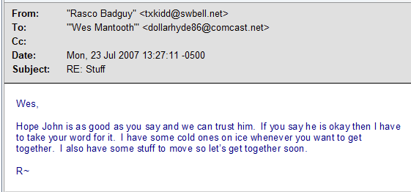
   2. Mantooth’s picture is below. This image was found along the following path: **C:\Unallocated Clusters\00000010_Unallocated_Clusters_FO-2594912_PS-94163+96.jpg.**

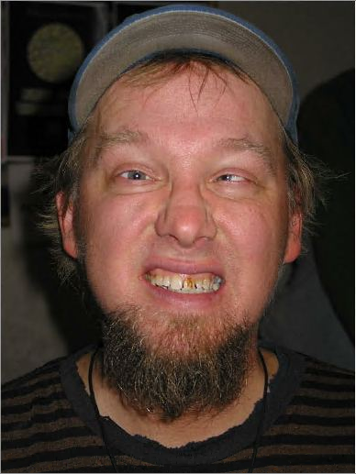

Figure 1: Wes Mantooth

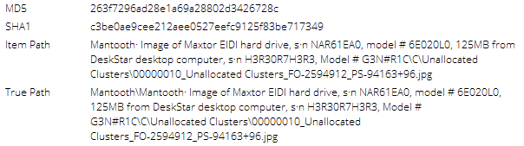

1. How many JPG files are available on the media in question?
   1. There are **306 jpg files** within the Mantooth forensic image. Using the following search query, , which turned up the following results. The 37 files with bad signatures or aliases instead of matches were excluded, leaving 306 files with matching hashes.

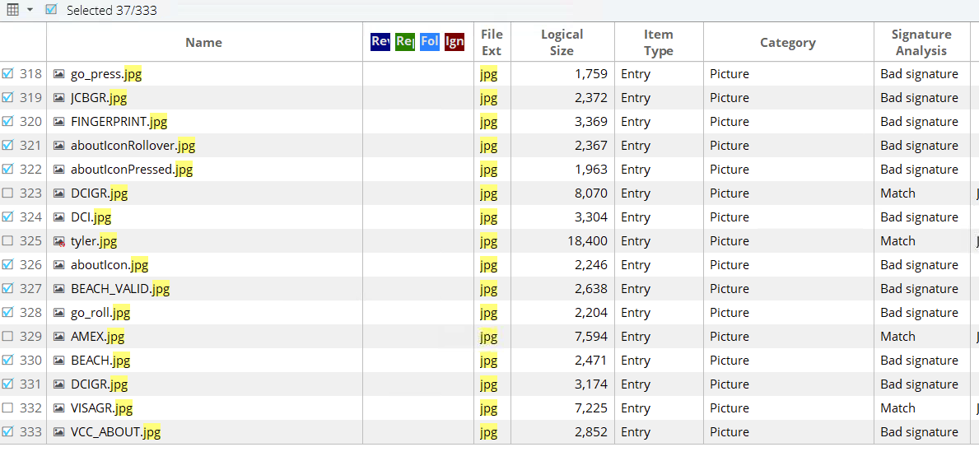

1. Provide Names of the domains that contacted Mantooth’s email address and list the number of occurrences, including the oldest and newest messages between Mantooth and the domain.

|  |  |  |  |  |  |
| --- | --- | --- | --- | --- | --- |
| **Sent** | **Oldest – Newest** | **Email Total** | **Received** | **Oldest – Newest** | **Email Total** |
| Comcast.net | 6/20/2007 – 6/21/2007 | 23 | Comcast.net | 6/20/2007 – 6/21/2007 | 8 |
| Aol.com | 6/20/2007 – 6/21/2007 | 2 | Aol.com | 6/20/2007 – 6/20/2007 | 6 |
| Swbell.net | 7/23/2007 – 8/4/2007 | 6 | Swbell.net | 8/1/2007 – 8/4/2007 | 2 |
| Microsoft.com | 6/20/2007 – 6/20/2007 | 1 |  |  |  |
| Gmail.com | 6/20/2007 – 6/21/2007 | 6 | Gmail.com | 6/21/2007 – 6/21/2007 | 3 |
| Mentaldental.com | 7/11/2007 | 1 | Mail.Vresp.com | 4/13/2007 – 5/11/2007 | 2 |
|  |  |  | Hotmail.com | 8/01/2007 | 2 |

1. Names of the People that have been sent or received emails from Mantooth and the number of emails between Mantooth and that person. The infroamtion from this table was retrieved using the indexed search function in EnCase and using the email search (item_type:3) in conjunction with the “to” and “from” fields, which were linked to each other using the Boolean “AND” search function.

|  |  |  |  |
| --- | --- | --- | --- |
| **Name** | **Emails** | **Sent (Last Sent)** | **Received (Last Received)** |
| John Washer  <chkwasher@comcast.net> | 3 | 3 (6/21/2007) | 3 (6/20/2007) |
| Mr. Smee  <smee.rox@gmail.com> | 6 |  | 6 (7/12/2007) |
| Rasco Badguy  <txkidd@swbell.net> | 6 | 5 (7/24/2007) | 1 (7/23/2007) |
| David Thomas  <skimmerman27@hotmail.com> | 2 | 1 (7/23/2007) | 1 (8/01/2007) |
| Mom  <toothfairy@mentaldental.com> | 1 | 1 (7/11/2007) |  |
| Laura Lee  <PGP_Corporation_Laura_Lee@mail.vresp.com> | 2 |  | 2 (5/11/2007) |
| Wes Mantooth  <washermeister@gmail.com> | 4 | 1 (6/21/2007) | 3 (6/20/2007) |
| Unidentified  <Molarman420@hotmail.com> | 1 |  |  |

1. Information on encryption, whether it was used and what type of encryption was used

The Suspect attempted to use PGP software to encrypt messages. Log files detailing the encryption attempts show that the attempts were mostly unsuccessful, outside of PGPlog3.txt which is shown below, showing various emails being processed, but not successfully encrypted.

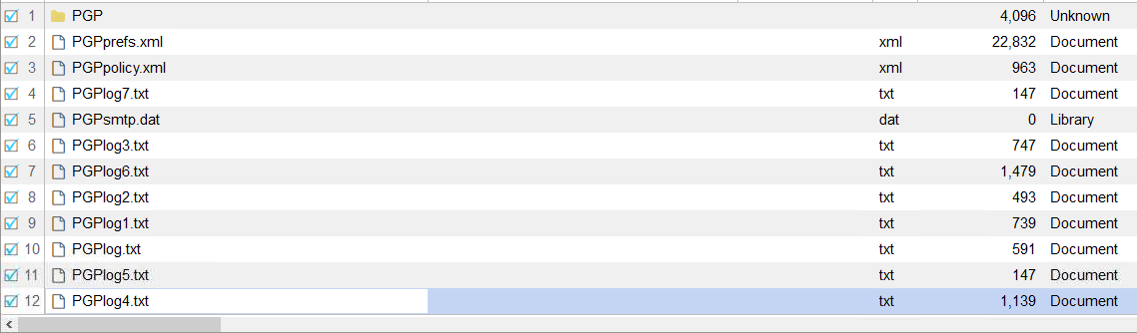

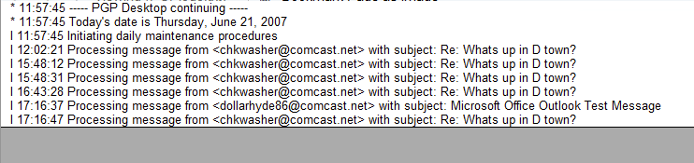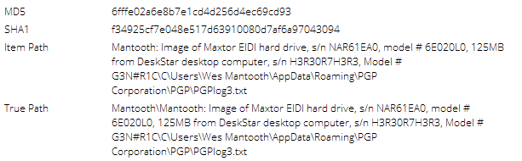

1. Evidence of Potential Criminal Activity within this image

Based on the evidence derived from the information in this forensic image, we can conclude that Mr. Mantooth was participating in multiple crimes:

**Check Washing:** Our search into the Suspect’s Hard Drive revealed that the suspect had multiple checks belonging to other individuals, and was keeping them for the purpose of writing fraudulent checks. Multiple searches were found on the suspect’s hard drive detailing “check washing” and other fraudulent activity. Matching hashes are provided to verify the origin of these images.

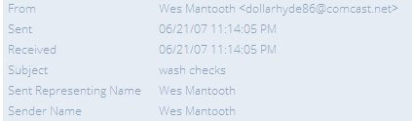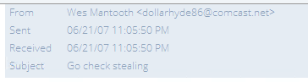

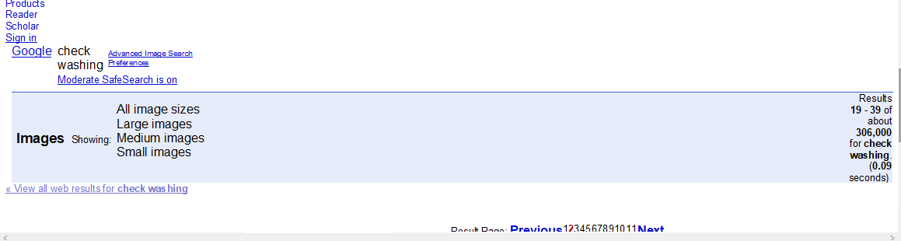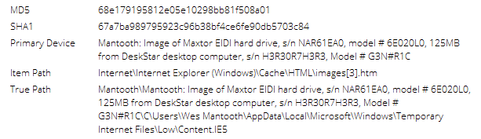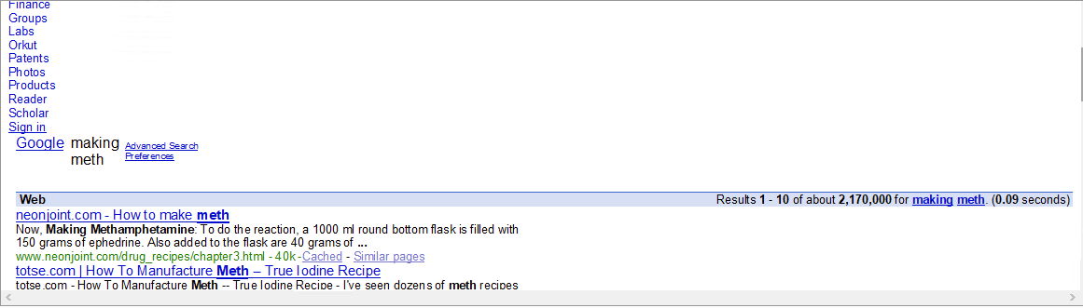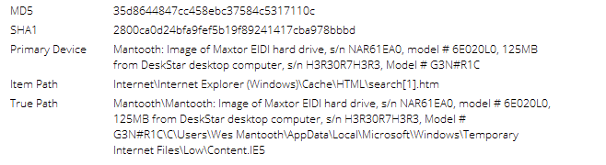

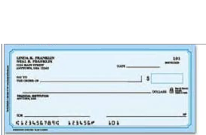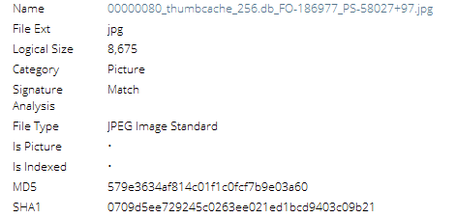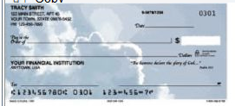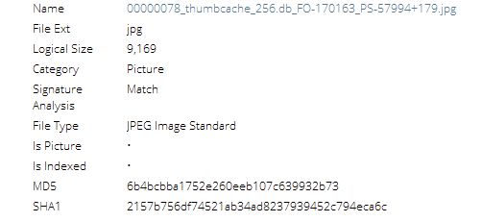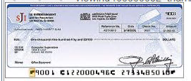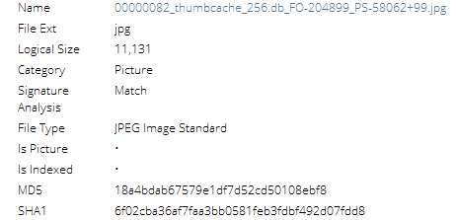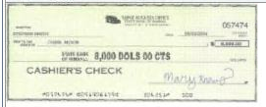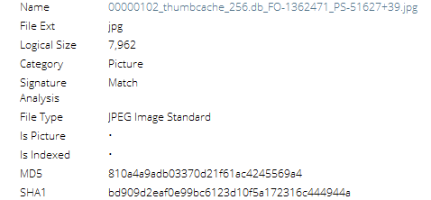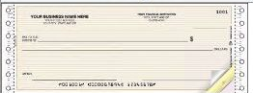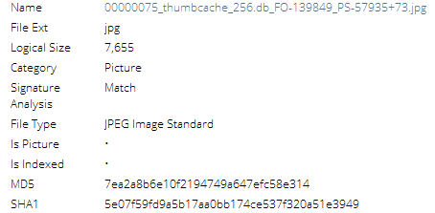

**ATM Credit Card Theft:** Our Team also found evidence that Mr. Mantooth was participating in a plan to steal credit card information using card readers. Below are emails and pictures of the equipment they would be using.

On Thursday, July 12th,2007, Wes Mantooth ([dollarhyde86@comcast.net](mailto:dollarhyde86@comcast.net)) sent a message to Mr. Smee ([smee.rox@gmail.com](mailto:smee.rox@gmail.com)) which was carbon copied to John Washer ([chkwasher@comcast.net](mailto:chkwasher@comcast.net)), titled “New Venture” containing the following message:

“I am thinking we should launch into a new venture…

Take a look at this and tell me what you think. I can get the parts for about $100.

Word”

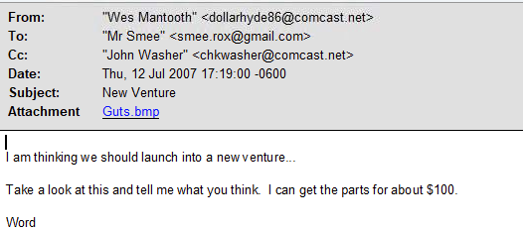

John Washer ([chkwasher@comcast.net](mailto:chkwasher@comcast.net)) replied to the message above on including both Wes Mantooth ([dollarhyde86@comcast.net](mailto:dollarhyde86@comcast.net)) and Mr. Smee ([Smee.Rox@gmail.com](mailto:Smee.Rox@gmail.com)) at Wednesday July 11th, 2007 at 2:27 PM:

“Sweet!

If that turns out to be too risky, a budy of mine showed me how to rig the machines to keep the cards… Then we shoulder surf the pin and get the card when they leave!

He got this from a SPAM chainletter!

I love it!”

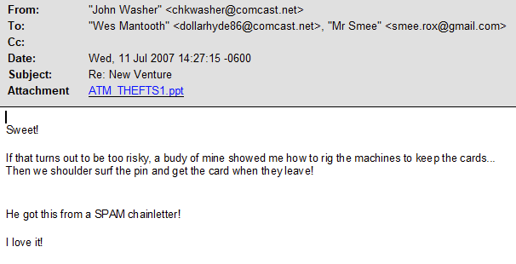

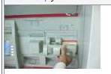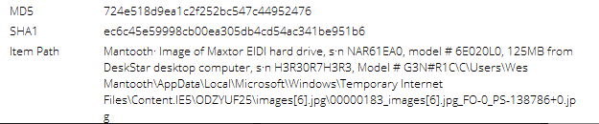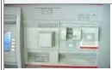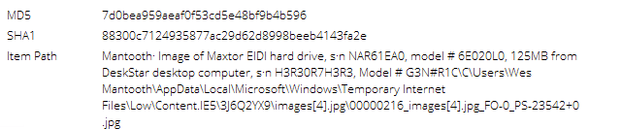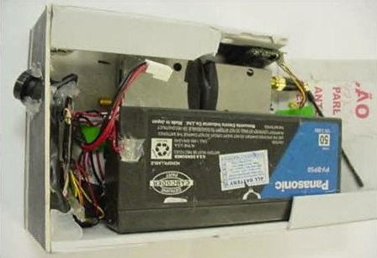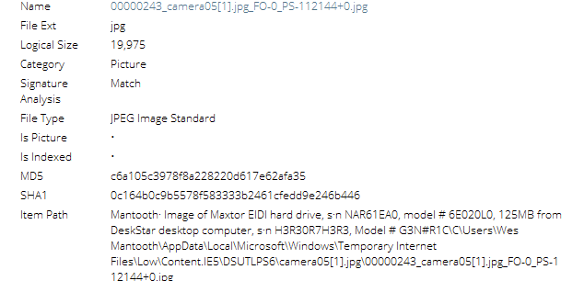



**Evidence of Stolen Car(s):** The suspect in question had copies of titles to cars which he did not own in the files contained in the forensic image. An email describing “how to steal cars”, and a copy of a title of a 1967 Chevy automobile registered to the state of New Jersey, but the name of the owner has been scrubbed out. There is also an edited

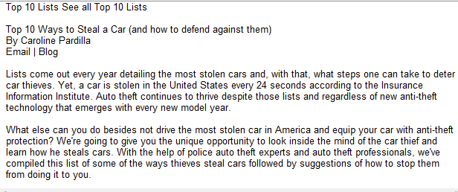

On Wednesday, June 20th, 2007, at 12:48 PM ([washermeister@gmail.com](mailto:washermeister@gmail.com)) sent an email to Wes Mantooth ([mantooth2007@aol.com](mailto:mantooth2007@aol.com)) an email titled “Here is Mine”:

“Here is a scan of my title. I got the car in a trade… I guess it is hot…

I was able to whip up this title in about 20 min.

Like pie and chips…for free!

Later”

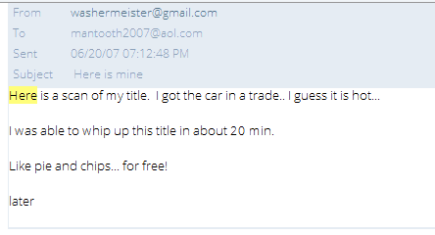

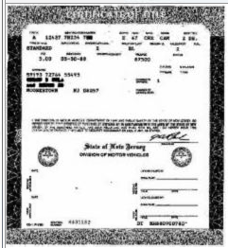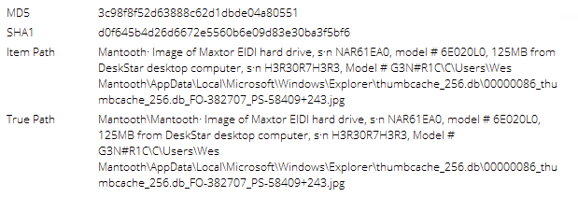

**Interest in Manufacturing Methamphetamines:**  Evidence retrieved from the forensic image indicates that Mr. Mantooth had conversations over email with co-conspirators regarding making and selling methamphetamines.

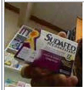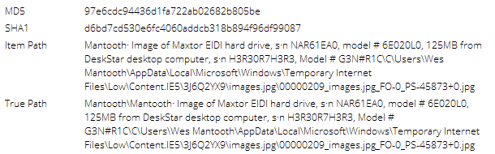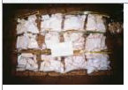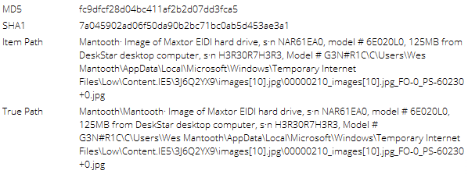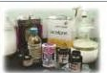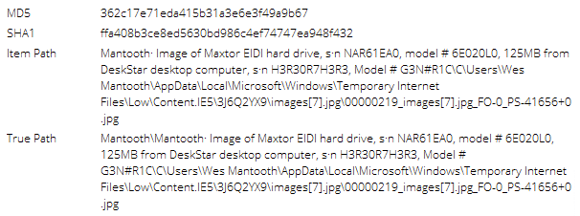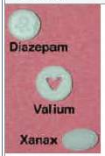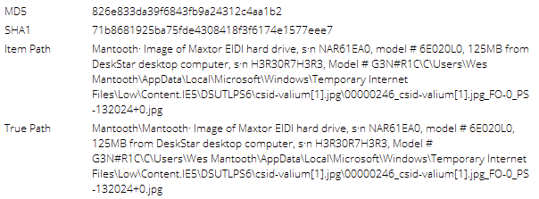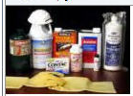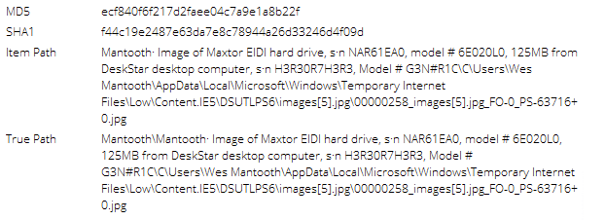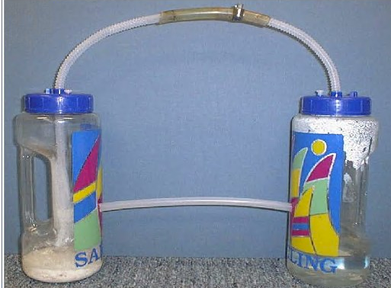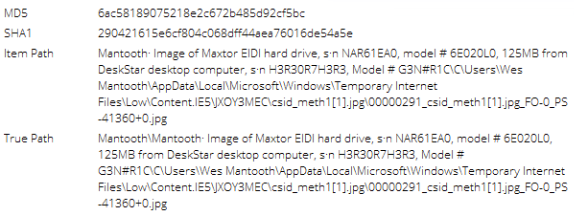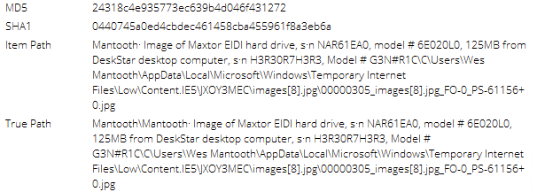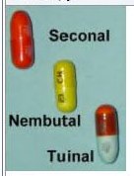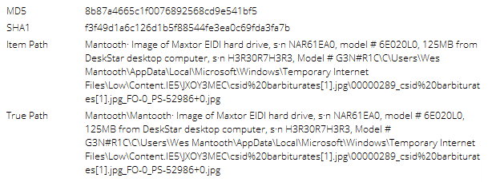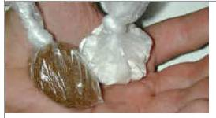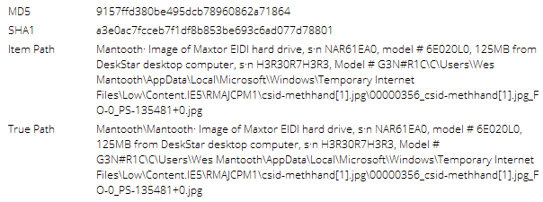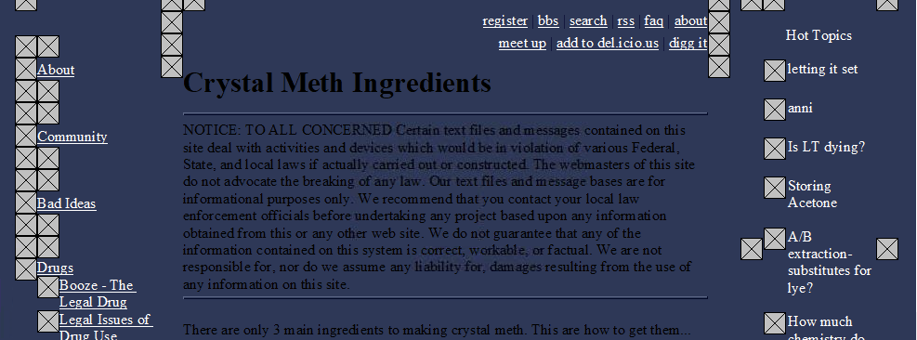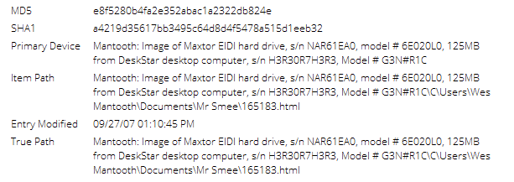

**Prescription Fraud:** Emails between Mr. Mantooth and co-conspirators as well as evidence found in the forensic image reveal that Mantooth was illegally obtaining pharmacy prescriptions.

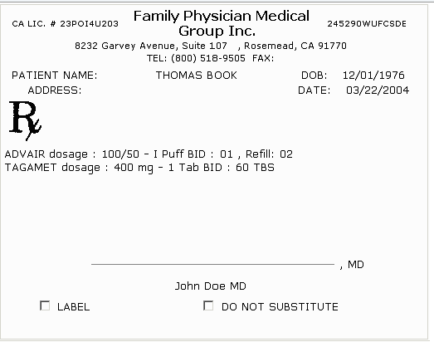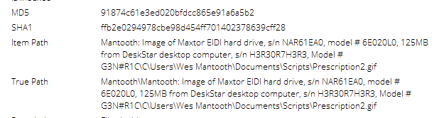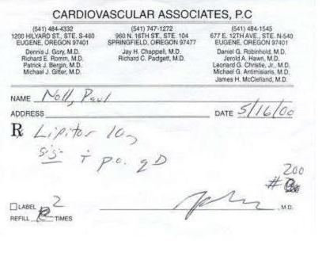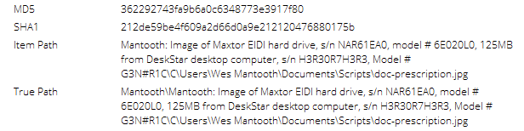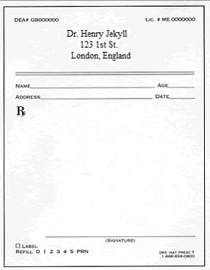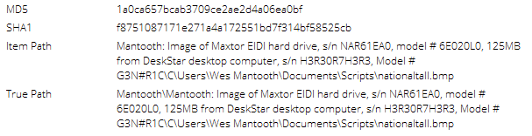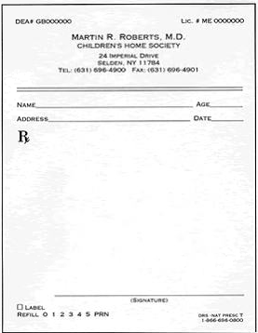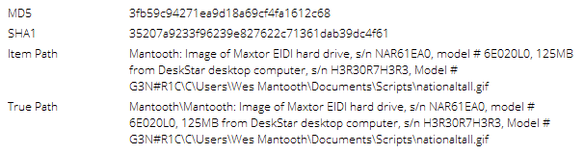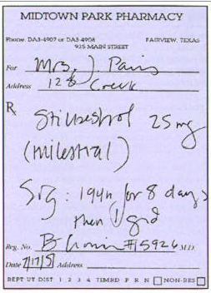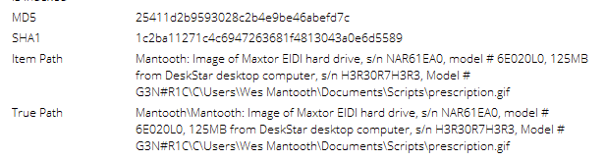

On Thursday, June 21st, 2007 at 6:00 PM, Wes Mantooth ([dollarhyde86@comcast.net](mailto:dollarhyde86@comcast.net)) sent an email to John Washer (chkwasher@comcast.net) , replying to an email titled “Whats up in D town?”

“Sorry man.

I have been a little under the weatherlately. Too much party!

Yea I am good to go…same time andplace.

I am hot on the trail of some good scripts…

Check this one out!

I need to do a little editing on the typeand quantity…but it shouldn’t be a problem

Later”

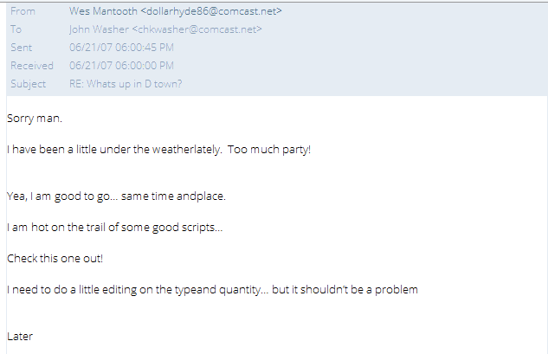

1. Information on how the PINs were captured

In Email communications with his co-conspirators, Mantooth attached a PowerPoint presentation that details how PIN numbers were retrieved in conjunction with aforementioned motives to steal Credit Card Information.

On Wednesday, July 11th, 2007, John Washer (chkwasher@comcast.net) wrote an email to Wes Mantooth (dollarhyde86@comcast.net), containing the following message:

“Sweet!

If that turns out to be too risky, a budy of mine showed me how to rig the machines to keep the cards… Then we shoulder surf the pin and get the card when they leave!

He got this from a SPAM chainletter!

I love it!”

Screenshots of the PowerPoint are supplied below.

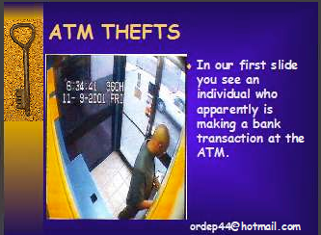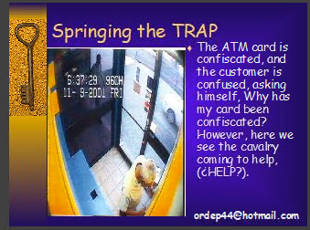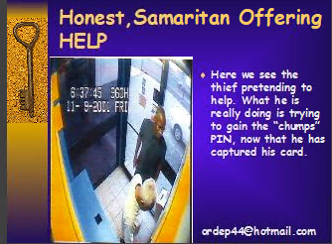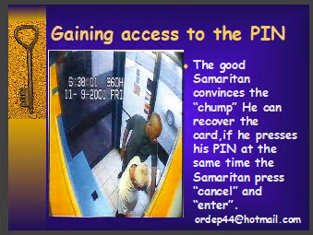

1. Vehicle Identification of the 1992 Dodge

The Vehicle Identification Number (VIN) of the 1992 Dodge linked to this case is **2B4GH2536NR5D4780.** The VIN was recovered from a picture I recovered of the title certificate of the vehicle. Hashes and verification of the title image are supplied below.

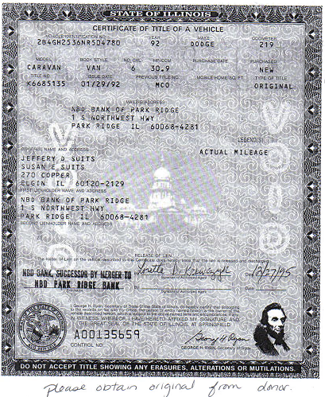

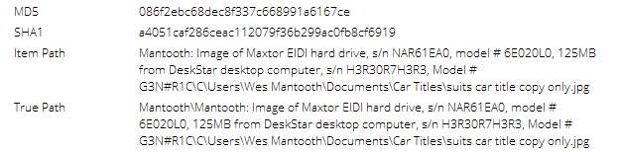

1. Identity of Sean and the role in this case

“Sean” most likely refers to **Sean P. Kane**, the owner of a check which appeared in the forensic imaging of Mantooth’s computer. Kane can be acknowledged as a victim.

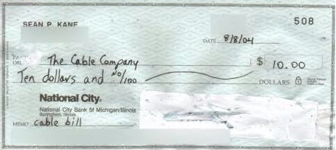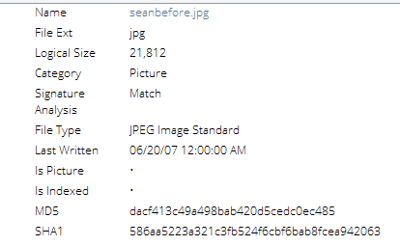

Figure 2 Seanbefore.jpg

Windows Event Log Parser function within EnCase. 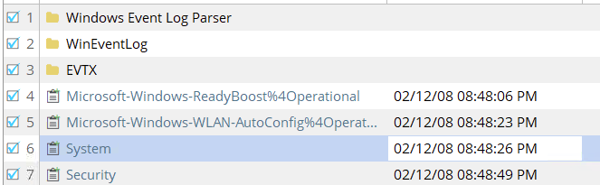

1. Information on Passwords

Using the Keyword Search Feature on EnCase, there was a search conducted on the Forensic Image that revealed 65 items when the term “password” was searched. That search brought about one file that contained a password, the readme-password.txt file, located in the following path: **C\Users\Wes Mantooth\Documents\ADS\readthis.txt.password.txt**, containing a message to be opened with the password “supercallifragilistic”.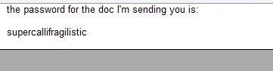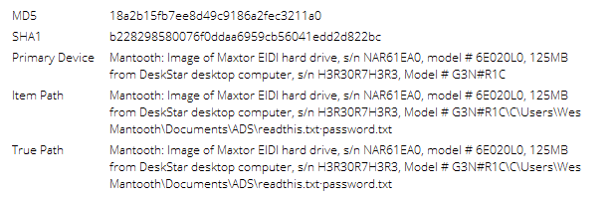

POLICE DEPARTMENT FORENSIC CASE REPORT

20201113-1001a 9/1/2021

**Washer, John**

* Credit Card Fraud
* ATM Fraud
* Check Washing
* Email Fraud/Phishing

**Examination of [media examined]:** On September 1st, 2021, Forensic Examiner *Ifeanyi Uzoukwu* conducted an examination of a Hard Drive and Thumbdrive at the request of Assistant District Attorney Gerald Kelser.  The allegations, per the request, were Credit Card Fraud, Check Washing, and Email Fraud/ Phishing.  This examination included a review of emails, documents, saved webpages, and downloaded images available on the hard-drive and thumbdrive in question in search of evidence related to the allegations.

**Search Authority:**

Authority to search was granted based upon a court issued search warrant (Mag No. 5:15-BR-549-TLC) Boulder Police Department.

**Items Analyzed:**

Images of the following hard drive and thumbdrive:

* Digital Image of Maxtor DiamondMax EIDI hard drive, s/n N07S4M3, model # 6E020L0, 125 MB from PlutoStar desktop computer, s/n 1M1N0C3N7, Model # GU1L7Y
* Digital Image of SanDisk Mini Cruzer, black/white, s/n 20043512300C4E62C465, 125MB

**General Procedure Followed:**

Forensic Examiner Ifeanyi Uzoukwu imaged the above described items and made a working copy of image files. The MD5 hashes 8218ee3f1f362d1186e0d14458ea01e7 (Washer) and 922f688e67d0b954354cafb5f72224b4 (Thumbdrive) and SHA-1 hashes 5707fee3ae50faf8187a0d7c96e7c50765bc8739 (Washer) and bed481bca1755c05ab6a519ff266f74b0502844f (Thumbdrive) of the working copy matched that of the original media. The evidence was checked into the evidence room and all examinations were conducted on the working copy.

Using EnCase Version 8.09, I examined the contents of the aforementioned hard drive, Keyword Search, Index Search, and File Carving searches were used to produce the following evidence.

**Executive Summary:**

The examination of the above describe item support the above-described allegations Email was discovered in this examination that suggest Mr. Wes Mantooth was in communication with Mr. John Washer pertaining to credit card information theft, check washing, and email fraud/phishing.

**Lab 3: Process an Image from Suspect Washer’s Computer and Thumbdrive**

Our Forensics Examiner Team also recovered a Forensic Image of Washer’s hard drive, and its contents provided the answers to many follow up questions our legal team had after the analysis of Mantooth’s hard drive was completed.

1. What are the AIM usernames for Rasco Badguy and John Washer?
   1. In an email conversation dated on Monday, July 23rd, 2007, Rasco Badguy ([txkidd@swbell.net](mailto:txkidd@swbell.net)) spoke to John Washer ([chkwasher@comcast.net](mailto:chkwasher@comcast.net)) in an email titled “IM?” and revealed that his AIM Username is **rbadguy2424.** Washer replied in a corresponding email replying to another email titled “Password”, that his username is **washergonebad.** Email frames and hashes are provided below.

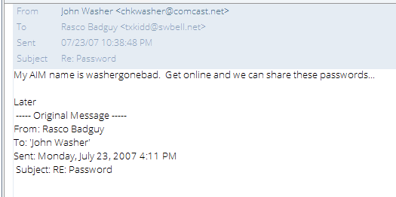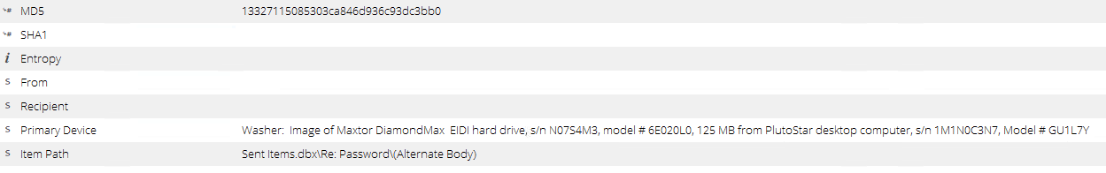

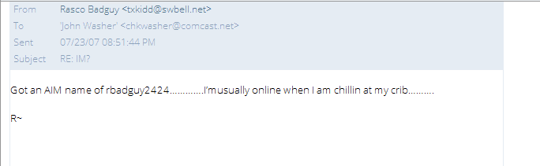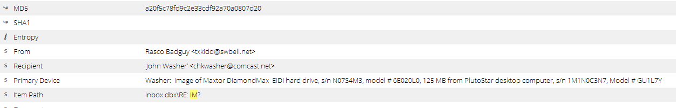

1. What is the current zip code for the AOL IM account registered to Washer?

During the analysis of the Washer forensic Image, information regarding this item was found but could not be parsed using the programs at our disposal. It is highly recommended that further analysis be conducted to find this information.

1. When was AOL IM installed?

AOL IM was installed on **7/25/2007**, as can be seen in the following images.

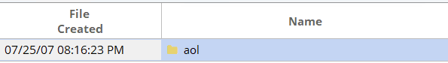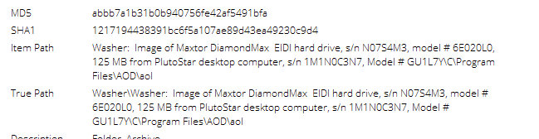

1. What does Rasco's vehicle look like? Provide a description. Who might Rasco bring with him?
   1. In an email dated on Tuesday, July 24th, 2007, Rasco Badguy ([txkidd@swbell.net](mailto:txkidd@swbell.net)) confirmed to Washer (chkwasher@comcast.net) that his vehicle is a Black Tahoe with “really nice” 22” wheels. In this email, Badguy also said that he might have Skimmerman accompany him on the camping trip. Screen shots and hashes are provided below.

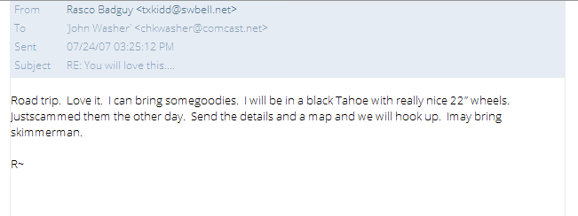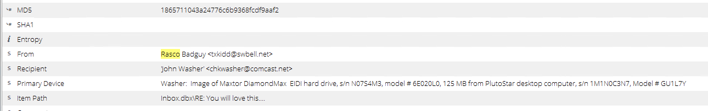

1. Provide the starting and ending points for their camping trip, as well as the name of the body of water nearby (same as the road running along the shore). Find a map and directions to the spot where they will camp.
   1. In an email dated on Tuesday, July 24th, 2007, John Washer ([chkwasher@comcast.net](mailto:chkwasher@comcast.net)) sent a message to Rasco Badguy ([txkidd@swbell.net](mailto:txkidd@swbell.net)), titled “Camping Directions”. In this email, Washer gived Badguy the directions to the Camping Site.
   2. The starting point for the camping trip is in **Texas, traveling East onto the TX-105** highway. The ending point is at the **Red Feather Lakes in Colorado**. The body of water near the Red Feather Lakes camping site is **Hiawatha Lake**, in Colorado.

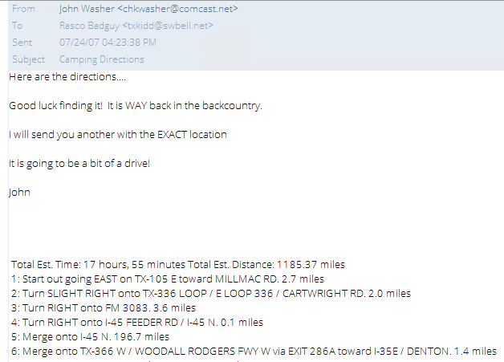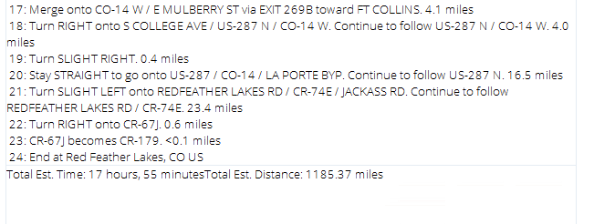

1. Document three distinct types of criminal activity that are under consideration and discussion by these individuals.
   1. Email Phishing
      1. On Wednesday, Aiugust 1st, 2007, Rasco Badguy (txkidd@swbell.net) sent an email to John Washer ([chkwasher@comcast.net](mailto:chkwasher@comcast.net)), Wes Mantooth ([dollarhyde86@comcast.net](mailto:dollarhyde86@comcast.net)), and an unidentified user (Molarman420@gmail.com) were communicating in an email titled “Letter”, about working on “gaining capital” and the attachment contained a PDF document titled “Confidential Business Letter.doc” that was a proposal address to the “President/CEO”, asking to assist in the transfer of millions of dollars from their bank accounts. Screen captures and hashes are provided below.

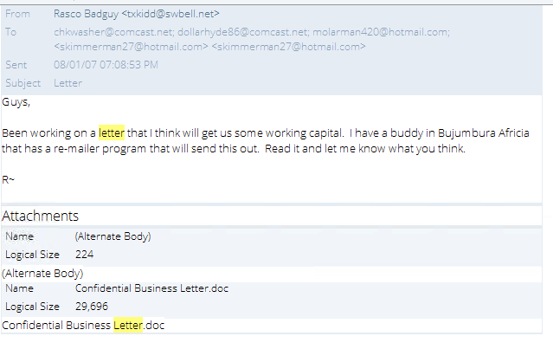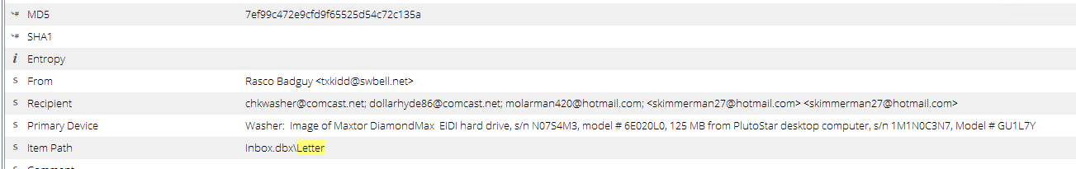

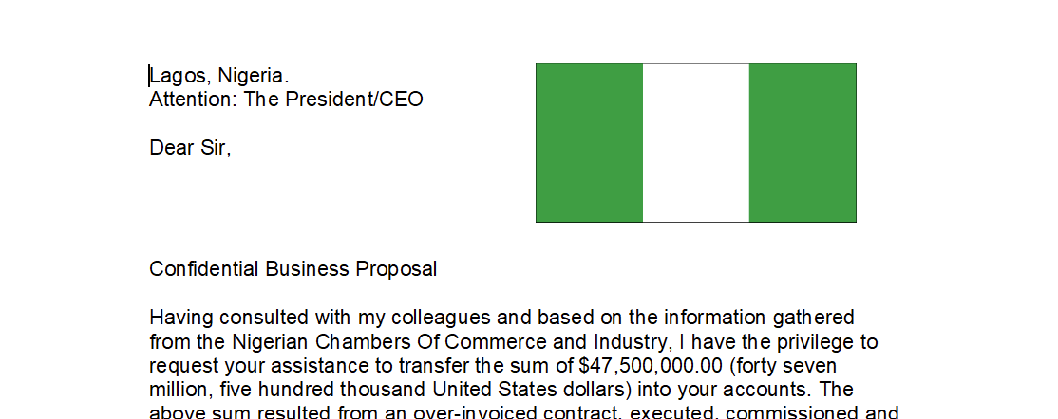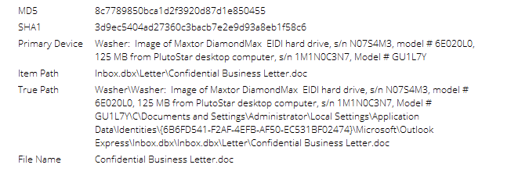

* 1. Credit Card Fraud
     1. On Wednesday, August 1st, 2007, David Thomas ([skimmerman27@hotmail.com](mailto:skimmerman27@hotmail.com)) replied to an email titled “Me and My Woman” to John Washer ([chkwasher@comcast.net](mailto:chkwasher@comcast.net)) saying he just “scored big” after a trip to New York. In the attachments to this email, Skimmerman provided what appears to be blank credit cards, and an array of credit cards from various financial institutions.

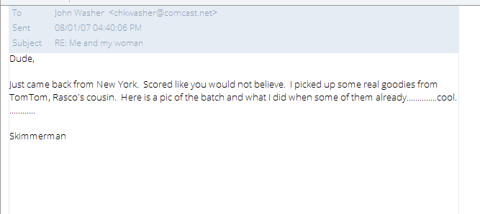

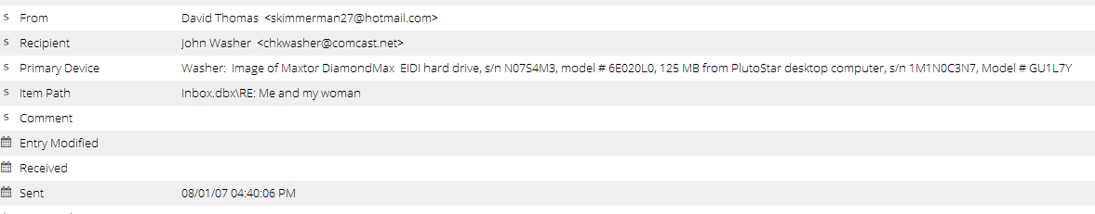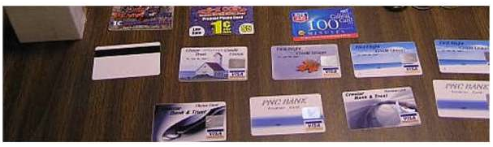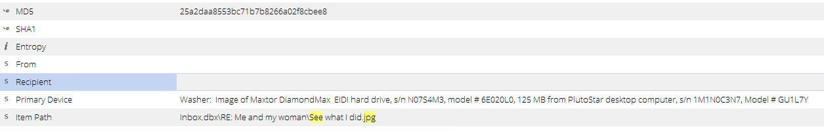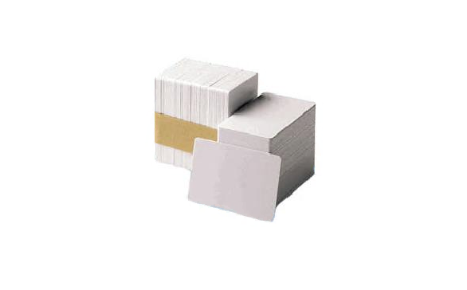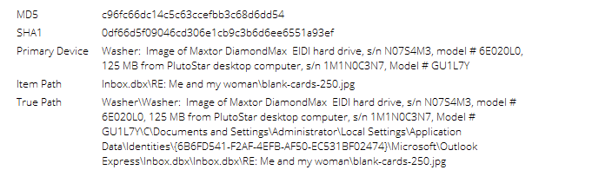

* 1. Prescription Fraud

On Thursday, June 21st, 2007, Wes Mantooth ([dollarhydee86@comcast.net](mailto:dollarhydee86@comcast.net)) replied to an email chain titled “Whats up in D town?”, to John Washer ([chkwasher@comacast.net](mailto:chkwasher@comacast.net)) asking him to check out the following image after confirming that he was “hot on the trail of some good scripts”. Screen captures and hashes are provided below.

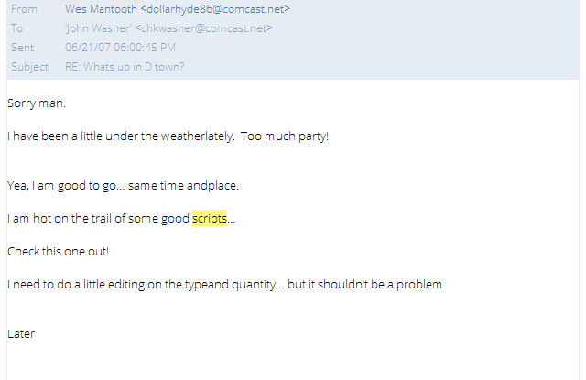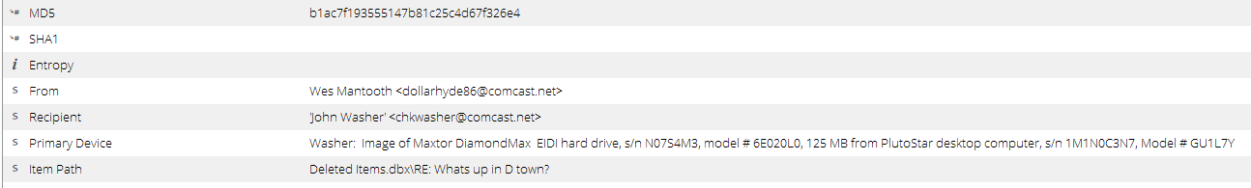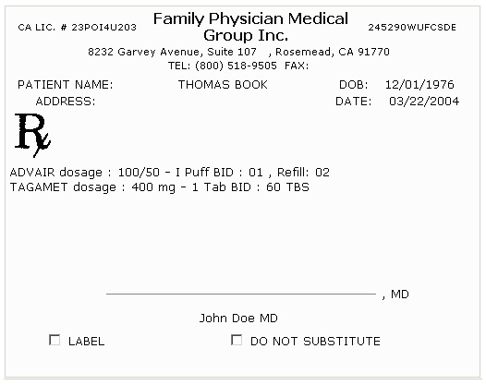

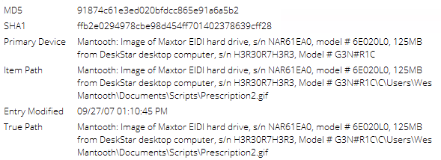

1. There is a piece of software that will support one of the types of criminal activity under consideration. It is being obscured by file manipulation or encryption. Document the name of the file, its function, and what needs to be installed for it to operate.

The software is known as “cool tool.piz”, a validator program. The program is being obfuscated by having the extension altered to “.piz” instead of “.zip”. Using the “cool tool.piz” file is supposed to work in conjunction with the “ValidateCreditCard.jar” file, which needs java to run correctly. On Monday, July 23rd, 2007, John Washer ([chkwasher@comcast.net](mailto:chkwasher@comcast.net)) sent an email to Rasco Badguy ([txkidd@swbell.net](mailto:txkidd@swbell.net)) titled “Thanks” in which the “cool tool.piz” file was attached. Screen shots and hases are provided below.

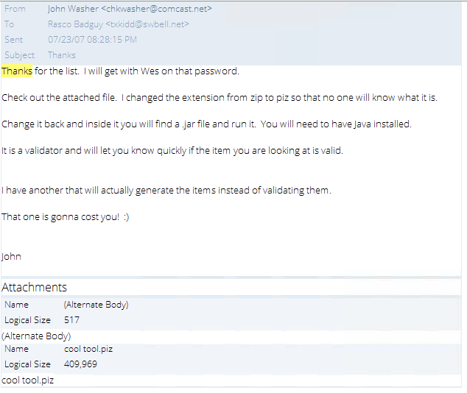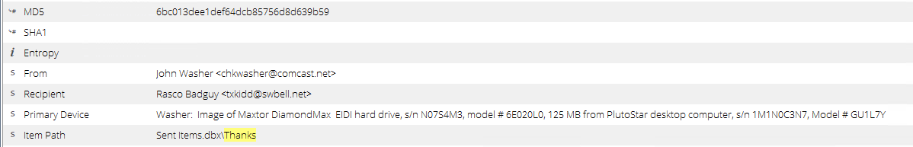

1. Document two names, addresses, and credit card or account numbers of potential victims.

In the email titled “Sweet Info” sent from Rasco Badguy ([txkidd@swbell.net](mailto:txkidd@swbell.net)) to John Washer (chkwasher@comcast.net) , Badguy mentions that friends of his were arrested in the news report document attached to the email. By switching to the transcript viewing function on EnCase, and scrolling to the bottom of the document, you can see the names of two people, Tom Smith and Bobby Jones, along with their addresses, and their account number information. Screen Captures and hashes are supplied below.

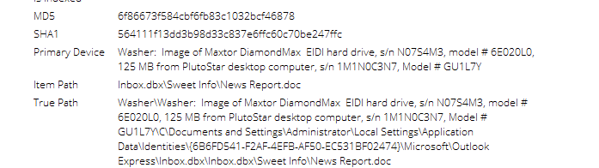

1. Prove that the file "How To Steal Credit Card Numbers.doc" was opened on the computer.

In an email from Rasco Badguy ([txkidd@swbell.net](mailto:txkidd@swbell.net)) to John Washer ([chkwasher@comcast.net](mailto:chkwasher@comcast.net)) also carbon copied to Wes Mantooth ([dollarhyde86@comcast.net](mailto:dollarhyde86@comcast.net)), sent on Monday, July 23rd, 2007, Badguy sent an email containing the “How to Steal Credit Cards.doc” file, which was opened up by Washer on the 25th of July. Screen captures and hashes are provided below.

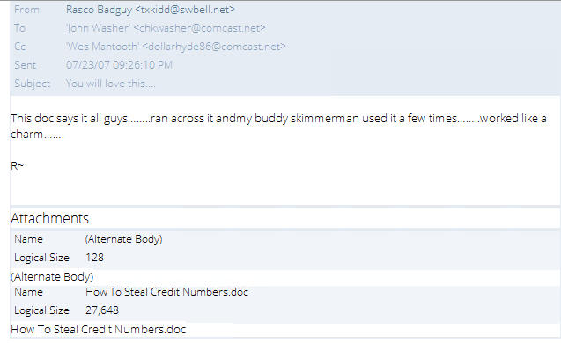

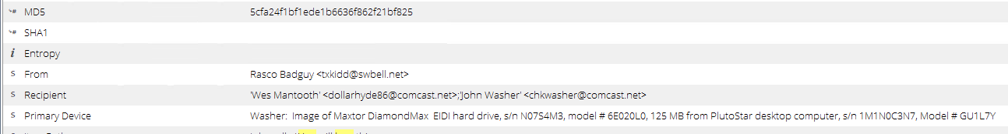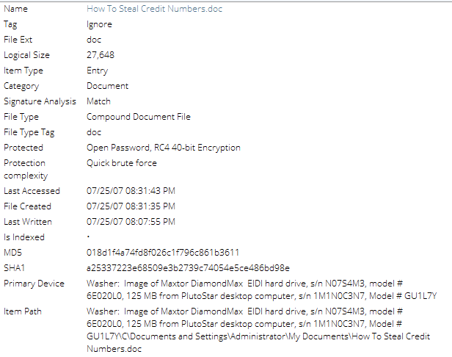

1. The word "oops" has come up in intercepted traffic. Document what it refers to.
   1. “Oops” likely refers to **“oops.jpg”**, an image that shows a construction crew misspelling the word “stop” while painting on the street. Instead, “sotp” was printed on the street.

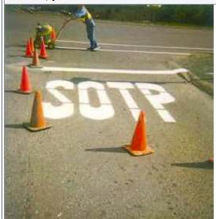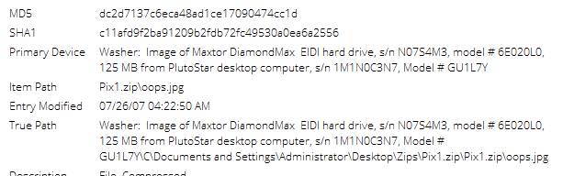

1. Document three ways this case has familiarity or linkages to any other case you are familiar with.

There is extensive evidence that links the Washer image to the Mantooth Image.

* Confidential Business Letter with Nigerian Flag Letterhead

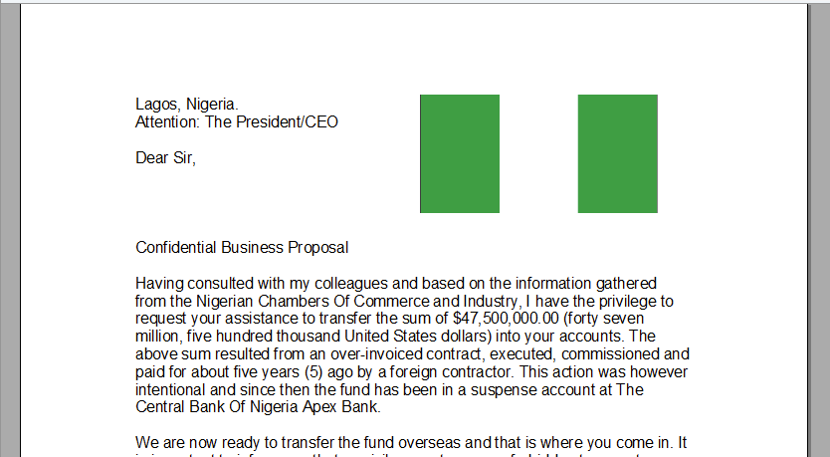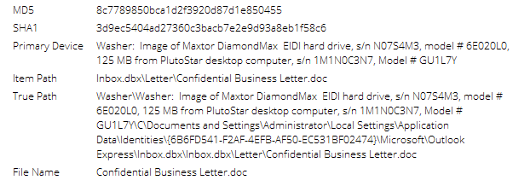

* Email Correspondence with Mantooth linking Washer and Mantooth
  + On June 21st, 2007, John Washer ([chkwasher@comcast.net](mailto:chkwasher@comcast.net)) wrote to Wes Mantooth ([dollarhyde86@comcast.net](mailto:dollarhyde86@comcast.net)), replying to an email titled “Whats Up in D town?” In which a conversation relating to check washing took place.
  + 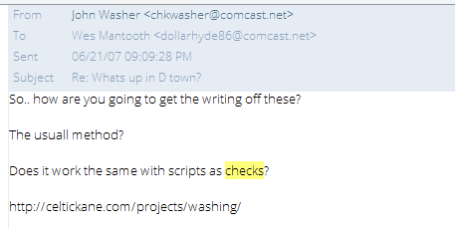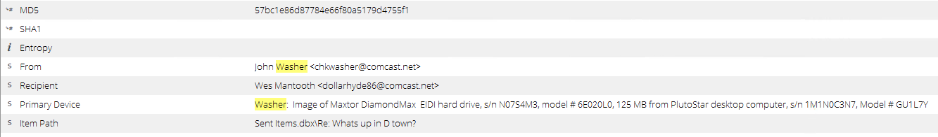
* Email Correspondence with other conspirators mentioning “Skimmerman”

Both Washer and Rasco Badguy had Contact with Skimmerman. In an email dated on Wednesday, August 1st, 2007, David Thomas ([skimmerman27@hotmail.com](mailto:skimmerman27@hotmail.com)) sent an email to John Washer ([chkwasher@comcast.net](mailto:chkwasher@comcast.net)) detailing his recent exploits in New York.



1. Several people in this case owe money. Document who they are and how much they owe.

During the analysis of the Washer forensic Image, information regarding this item was found but could not be parsed using the programs at our disposal. It is highly recommended that further analysis be conducted to find this information.

1. Is there anything that links the thumb drive to the Washer image?

There are multiple links between the Thumbdrive and the Washer Image. Both images contain links to the Powerpoint on stealing cards information from ATM machines.

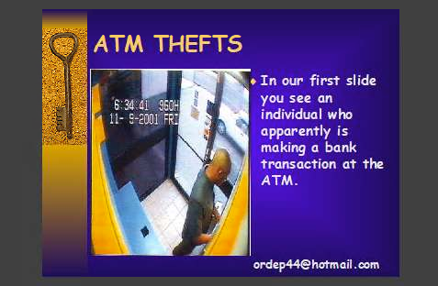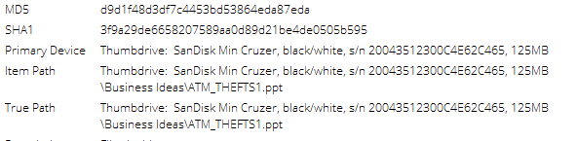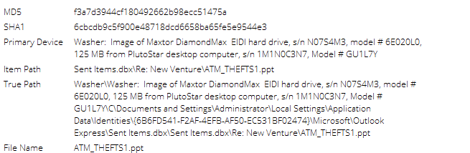

Evidence of ATM Machine Manipulation on both images

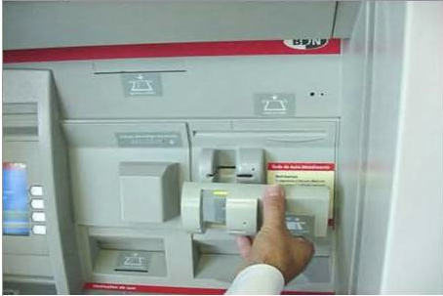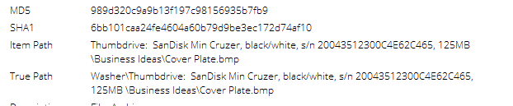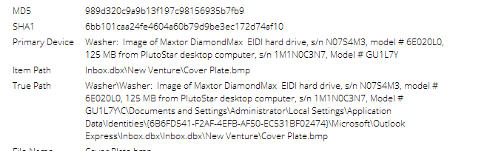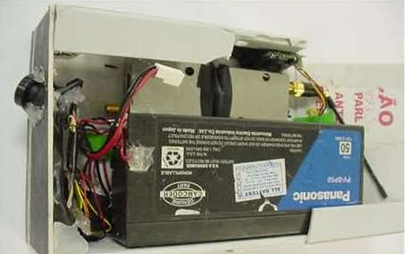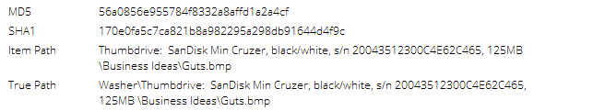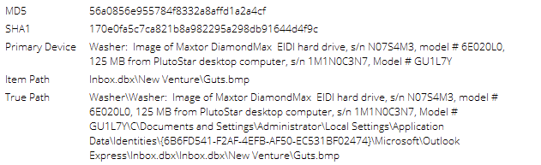

1. Document how many times the administrator account was used and the date of the last log-in

During the analysis of the Washer forensic Image, information regarding this item was found but could not be parsed using the programs at our disposal. It is highly recommended that further analysis be conducted to find this information.

**Summary of Findings**

There is extensive evidence to link the following individuals to a criminal enterprise:

* John Washer
* Rasco Badguy
* Wes Mantooth
* David Thomas A.K.A “Skimmerman”
* Mr. Smee

The Analysis of the Mantooth.E01, Thumbdrive.E01, and Washer.E01 files reveal evidence of:

* File Obfuscation
* ATM/Credit Card Fraud
* Vehicle Title Fraud
* Check Washing
* Intention to Manufacture Drugs (Methamphetamines)

The preceding reports provided sufficient evidence to launch an investigation into the lives of the five individuals noted above.

**IMAGE VERIFICATION HASHES**

